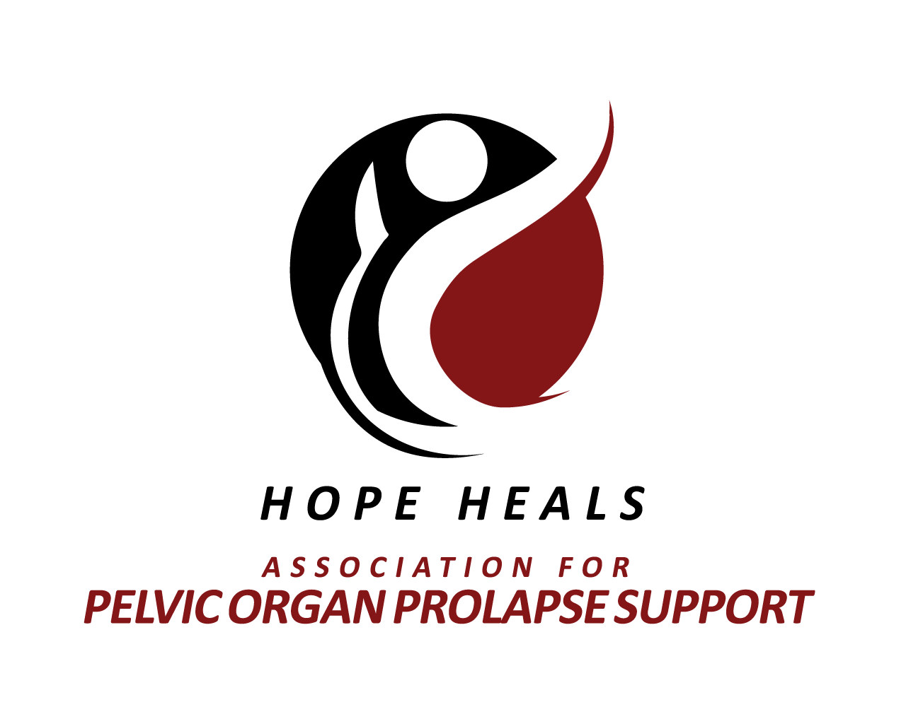

STIGMA*STRIDE
ADVANCING AWARENESS OF WOMEN’S PELVIC HEALTH

Implementing Agent: Sherrie Palm, APOPS Founder/Executive Director
262-441-0488
Sherriepalm.apops@gmail.com

STIGMASTRIDE PROPOSAL

Introduction:
“The real story about pelvic organ prolapse and incontinence is not that embarrassing conditions and symptoms exist; the story is about impact to women’s lives and that after 4000 years on medical record, health concerns remain stuffed in the closet.” ~Sherrie Palm
Association for Pelvic Organ Prolapse Support (APOPS) project proposal is an instrument to generate reduction of stigma related to pelvic organ prolapse (POP) and its common symptom incontinence, as well as spawn broad-spectrum awareness and understanding of these health concerns. APOPS is a US based 501(c)(3) founded in 2010 in Mukwonago, Wisconsin.
Pelvic organ prolapse is an extremely common women’s health concern that has been on medical record for over 4000 years yet remains shrouded in silence because of embarrassing symptoms such as incontinence and vaginal tissue bulge.
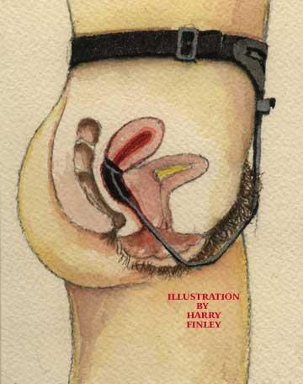
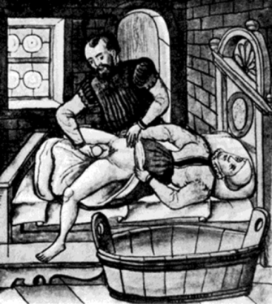
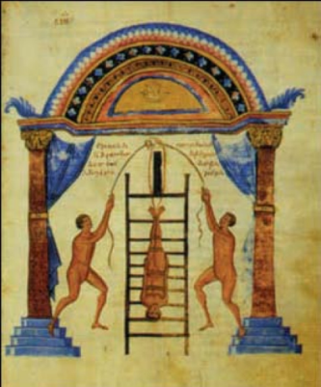
Hippocratic Succussion Kahun Papyrus POP Treatment Pessary 1867
APOPS primary goals and objectives are:
- Generate awareness of pelvic organ prolapse of all ages, particularly prior to pregnancy.
- Provide guidance and support to women navigating POP.
- Reduce stigma related to incontinence and tissue bulge.
- Capture accurate statistics.
- Encourage diagnostic practitioner educational curriculum evolution.
- Encourage screening protocol evolution.
Networking with healthcare, industry, research, academia, advocacy, and most importantly, the women we serve, APOPS builds bridges to advance pelvic organ prolapse awareness and perception.
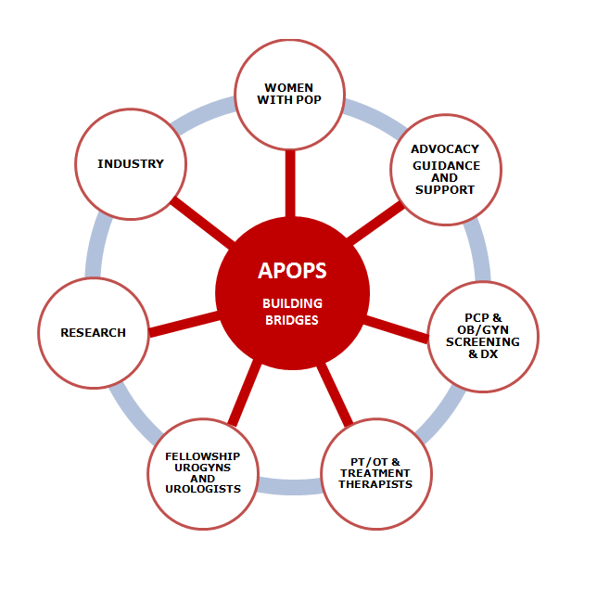
Stigma keeps topics such as pelvic organ prolapse and incontinence in the closet despite medical record documentation. Discovery upon diagnosis is the norm with pelvic organ prolapse; women seldom talk about the condition post diagnosis because of embarrassing symptoms such as incontinence and vaginal tissue bulge. Typically considered a health condition of mature women, there is significant need to establish recognition that incontinence is a symptom of an underlying condition, rather than a disease that stands alone. Childbirth is the leading cause of POP; women should be informed of signs and symptoms that may be indicative of POP such as incontinence and vaginal tissue bulge prior to pregnancy. APOPS stance is pelvic organ prolapse and incontinence should be talked about out loud, generating awareness and reducing stigma, similar to what has occurred with breast health awareness via the Komen Pink Ribbon Campaign and erectile dysfunction via the Viagra little blue pill campaign. Pelvic organ prolapse and incontinence are health concerns, nothing more, nothing less.
“Pelvic organ prolapse is seldom life threatening, but it is always life altering.” ~Sherrie Palm
QUALIFICATIONS TO ADVANCE THE INITIATIVE:
- Vocal expression of all aspects of pelvic organ prolapse via APOPS advocacy initiatives, book on pelvic organ prolapse written to address the needs of lay women, media exposure (radio and television), social media (FB, TW, LI, G+, Pinterest), FB based support chatroom, website educational materials, archived articles (both website and national/international online and print magazines), and presentation to the FDA.
- Networked with diverse national and international government agencies, health advocacy agencies, healthcare practitioners and organizations, research fellows, industry experts, and most importantly, the women navigating pelvic organ prolapse.
- Participation in Pelvic Floor Disorder Registry (PFDR) Stakeholder Board & NAFC Advisory Board committee.
- Scientific abstracts and poster presentations at scientific meetings and conferences.
- Engage vocally every opportunity presented in women’s pelvic floor health advocacy related to POP and incontinence concerns.
- APOPS initiatives: App in development, June POP Awareness Month, Squeeze Please initiative, WHEN developing zone campaign.
- Sherrie Palm Curriculum Vitae available upon request.

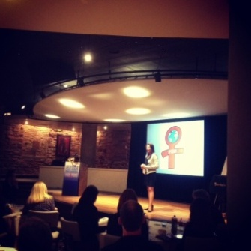
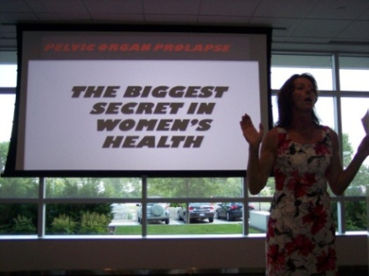

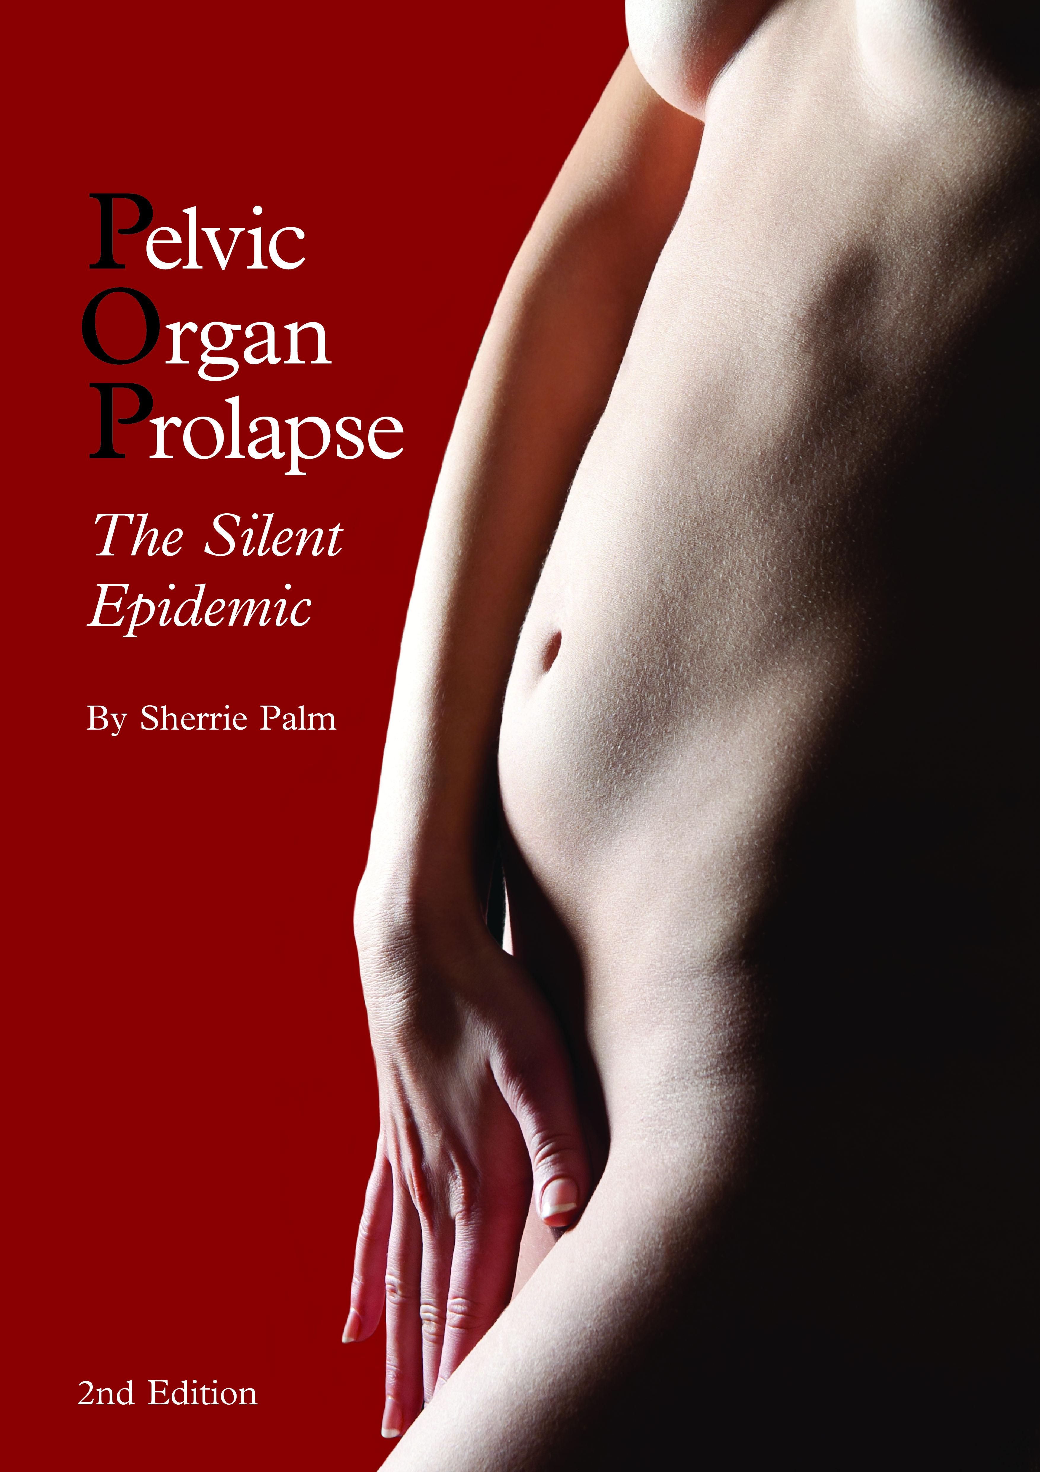
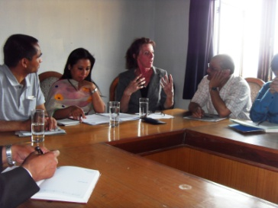
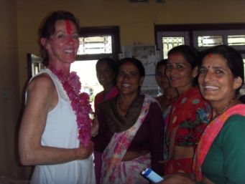

“Millions of women worldwide suffer in silence from the physical, emotional, social, and sexual ramifications of POP; awareness of pelvic organ prolapse will only occur when we share what we know with others. As we continue to nurture, guide, and network with women navigating pelvic organ prolapse, POP will soon become common knowledge.” ~Sherrie Palm
Benefit:
- Reduce stigma of embarrassing symptoms.
- Educate and generate open dialogue to increase common knowledge and understanding.
- Diminish myths.
- Engage people from all walks of life regardless of age, financial status, race, nationality, or employment demographic.
Project mission:
Stigma produces a veil that shrouds pelvic organ prolapse and incontinence in silence; generating open dialogue is pivotal to increase awareness of and initiate open dialogue regarding these health concerns similar to what has occurred with breast cancer and erectile dysfunction awareness campaigns.
PROPOSAL PURPOSE:
Generate awareness of pelvic organ prolapse and the symptoms which present such as incontinence and vaginal tissue bulge are high on APOPS initiative radar; reducing stigma related to these symptoms is of the highest priority. It is imperative we reach out to everyone including youth regarding all projects, programs, and initiatives. Open dialogue to discuss uncomfortable health topics in multiple settings and formats generates a comfort zone. Thirty years ago few spoke out loud about breast cancer. Fifteen years ago few spoke out loud about erectile dysfunction. Open dialogue has brought both of these conditions along with many others out into the open.
- Initiate an annual international awareness event/campaign to generate open dialogue about pelvic organ prolapse and incontinence.
- Bridge healthcare, industry, advocacy, and the communities they serve in a common goal to overcome stigma related to pelvic organ prolapse and incontinence.
Project perimeters:
- Global 24 hour initiative to engender internationally coordinated Walkathon and Giving Day events in June 2015 to generate awareness of commonality of pelvic organ prolapse and incontinence and make these topics acceptable to talk about out loud.
- Involve sponsors and endorsers from multiple avenues engaged in POP and incontinence directives.
- Involve the lay community to enable those suffering in silence a platform to participate, engage, support, and be supported.
SOLUTION:
Diverse methodology will be initiated to secure broad spectrum engagement from multiple sectors with overlapping interests and needs.
- Sponsorship levels.
- Endorsement from and participation by healthcare organizations.
- Endorsement from and participation by industry sponsors in pelvic organ prolapse and incontinence sectors.
- Endorsement from and participation by industry sponsorship from water and food sectors.
- Intracompany competition.
- Employer/employee match potential.
- Coupon product promo.
- Lay community participation.
Tooling:
- Web presence, newsletter, eblast, social media exposure.
- Facebook.
- Twitter.
- LinkedIn.
- Google+.
- YouTube.
- Chatroom.
- Organizational guideline templates.
- General guidelines.
- Event location exploration.
- Expense considerations.
- Registration.
- Publicity.
- Set up/break down.
- Food and beverage considerations.
- Sponsorship.
- Entertainment.
- Recognition.
- First Aid.
- Signage templates.
- Walkathon and Giving Day Steps to Success flyer templates.
- Goody bag suggestions.
BUDGET:
Event will require independent budget consideration for Milwaukee based corporate event as well as assistance and tracking for sister events hosted both inside and outside US borders. Individual event hosts will be responsible for their program development and budget needs; APOPS will provide event guidelines and checklists, promotional templates, and direction. Budget detail is included in appendix.
SUCCESS MEASURES:
Multiple measureable factors indicate success of a walkathon. Attaining event goals and objectives is of most significant value; reducing stigma and increasing awareness of pelvic organ prolapse and incontinence, generating patient, practitioner, and industry dialogue, and spawning media exposure are pivotal and necessary end points to produce essential evolution in women’s pelvic health consciousness.
- First year outcome measure aspirations.
- Twenty walkathons planned throughout US during scheduled period.
- Five walkathons planned in countries outside the US during scheduled period.
- Raise $75,000.
- Financial metrics.
- Sponsors.
- Participants.
- Online donations.
- Giving Day online events.
- Event attendance.
- By location.
- Number of locations participating.
- Effective awareness impact.
- Participant feedback.
Budget details available upon sponsor request.
APPENDIX:
- Sponsorship and endorsement criteria and requirements.

APPENDIX
Sponsorship Levels and Requirements

APOPS Walkathon sponsorship value:
- Enhance corporate brand name recognition.
- Promote positive publicity.
- Facilitate product awareness.
- Generate good will among employees.
- Nurture cross-sector relationship building in POP and incontinence arenas.
- Generate public responsiveness to connection between awareness and stigma reduction.

SPONSORSHIP REGISTRATION AND FEES MUST BE SUBMITTED PRIOR TO DECEMBER 15, 2014, TO EXPEDITE EVENT PROMOTIONAL PLANNING.

Platinum: $10,000 donation (one principal donor).
Requirement*Host Walkathon or Giving Day event.
- Exhibit promotional banner.
- Premium logo placement on all marketing materials.
- Premium logo placement on APOPS event and sponsorship web pages.
- Full page color ad in event program.
- Acknowledgment from podium at pre and post event greetings.
- Event goodie bag logo placement.
- 4 passes to post-event dinner.

Gold: $7500 donation.
Requirement*Host Walkathon or Giving Day event.
- Logo placement on all marketing materials.
- Logo placement on APOPS event and sponsorship web pages.
- Half page color ad in event program.
- Goodie bag insert.
- 2 passes to post-event dinner.

Silver: $5000 donation.
Requirement*Host Walkathon or Giving Day event.
- Logo placement on APOPS event and sponsorship web pages.
- Quarter page color ad in event program.
- Goodie bag insert.

Bronze: $3000 donation.
Requirement*Host Walkathon or Giving Day event.
- Logo placement on APOPS event and sponsorship web pages.
- Company name line insert in event program.

White: $500-$1000 or Host a Walkathon or Giving Day event
- Name placement on APOPS event and sponsorship web pages.
APOPS Allies: Donations $100-$499.
Requirement*Event placement on host website and distribution to eblast lists.
- Name placement on APOPS sponsorship page.
APOPS Allies: Host a Walkathon or Giving Day.
Requirement*Event placement on host website and distribution to eblast lists.
- Name placement on APOPS sponsorship page.

Marketing materials will be provided to event hosts upon completion of event registration and validation of host registration details.

Endorsement Criteria and Requirements

Healthcare, advocacy, and other organizations willing to broadcast APOPS Stigma*Stride Walkathon to their members and constituents will be listed on the sponsorship page under endorsements.

