Please contact First Impressions Promotions to access a Return Authorization Code for returned merchandise.
RETURN MERCHANDISE AUTHORIZATION
Phone: 408-667-8034 Email:firstimpressionspromo@yahoo.com
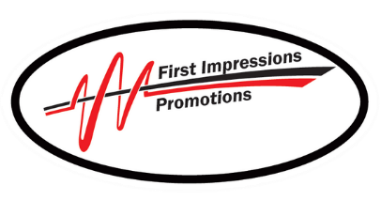
First Impressions Promotion
245 Brandy Hill Rd
Vernon, CT 06066
408-667-8034
firstimpressionspromo@yahoo.com

Damage Description Please email a picture of product and packaging damage with return authorization.
Return authorization number __________
Return authorization date _____________
Return received on ___________________
Credit issued on______________________
Reason for refund or exchange:
1. Arrived damaged or defective (no return necessary, email image of damage to item and containment box required).
2. Received wrong item.
3. No longer needed.
4. Did not meet customer expectations.
5. Does not fit.
6. Other (explain on Return Authorization Request form).
Claim Type
Refund ____ Exchange ____ Code # ____
Email address
Address
Name

Date
City, State, Zip

